**Lent 5 2020 Macedon Ranges Partnership worship**

*This is the second edition of worship suggestions. Consider printing a copy or two and dropping it into someone who does not have a computer, internet access or who is not particularly tech savvy.*

*Why not ring someone who also is not able to attend worship and share the prayers together. Pray for each other over the phone. Do this at the time you would have otherwise met to worship. Read and discuss the readings and the reflection.*

*You may like to collect a candle and light it as a sign that the light of Christ shines even into dark places and times. Open your Bible to the readings for today (Ezekiel 37:1 – 14 and John 11). Collect something to eat and drink for later in the service just before the Thanksgiving Prayer.*

*You may like to also use some music during the service. Sons of Korah’s version of Psalm 130 can be viewed on YouTube. Ann Scull suggests 3 other songs you could use. They are* ***Panis Angelicus*** *by Russel Watson on his album, The Voice,* ***You Raise Me Up*** *by Selah on their album, Hiding Place and* ***Out of the Depths*** *by Sinead O'Conner and found on her double album Theology. You can access each of these on YouTube as well. The song* ***You Raise Me Up*** *has been sung by many singers.* ***Out of the Depths*** *is also based on the Psalm.*

*If you would like to watch the video of this service, go to* [*https://youtu.be/m3D8qjZzXfQ*](https://youtu.be/m3D8qjZzXfQ)*. Copy and paste this link into your browser and it will take you to the YouTube page with the video. Just click the play arrow on the video to watch. You can download the video with a YouTube downloader and watch it as suits. YouTube downloaders are common and easy to use. Speak to Rev Peter for information and how to use one. If you have any problems with watching the video, give Rev Peter a call on 0418 570 013.*

*The text below is from the video service. The prayers are as used in the video as well. The reflection differs from the video.*

**THE SERVICE**

Welcome everyone to our scattered but together worship service on this the first of many, or maybe only video’d service. You may not find this works for you, so please give us feedback of what you would find most helpful in what may be a long time before we can meet face to face again.

Firstly let us acknowledge all the Aboriginal Groups who have cared and nurtured the land on which we meet: the Wurundjei; Woi Wurruung; Tuangurang and Dja Dja Wurrung.

We acknowledge their leaders: past, present and emerging for it is in them that Australia’s future lies.

**CALL TO WORSHIP:** (inspired by John 11: 1-45) *(~ Adapted from: Nancy Johnson, and posted on Wonderings through life and other such nonsense.* [*http://ruminari.wordpress.com/*](http://ruminari.wordpress.com/)*)*

Holy God, Creator of Life,  
you call us out of our dark places,

offering us the grace of new life.  
When we see nothing but hopelessness,

you surprise us with the breath of your spirit.

Call us out of our complacency and bonds and ,  
set us free from our government and self-imposed bonds,  
and fill us with your spirit of life, compassion, and peace,  
In the name of Jesus, your anointed one.  **Amen.**

**PRAYER:** *(~ Adapted from Rachel Hackenberg.  Posted on RevGalBlogPals.* [*http://revgalblogpals.org*](http://revgalblogpals.org)*)*

Restore us, O Living God, by the breath of your Spirit.  
We are wilted and weary on this Covid journey toward Easter,  
anxious for Restoration to come once and for all.  
  
Hear our voices crying out amidst the (isolation and) the ashes,  
where we hide in our homes to wait for a new day.

Ah, but let us not be bound to the earth by our weariness and tears,  
but rather swirled about and lifted up by the wonder of your life within us!  
  
Revive us, Creator, Compassionate God!  
There are crosses to carry and (maybe Hot cross buns and ) Easter eggs to enjoy!  
There is praise to give and work to be done and surprising life to nurture!  
No matter our tired bones, you are not finished.  
By your goodness and grace, we are not finished! **Amen**

**READINGS:**

*Feel free to read the Bible readings in your preferred version. The readings for Lent 5 are Psalm 130 and Romans 8:6 – 11 and the ones used in our worship video:*

**Ezekiel 37:1 – 14**

**John 11**

*Valley of Dry Bones by Norman Swindells*

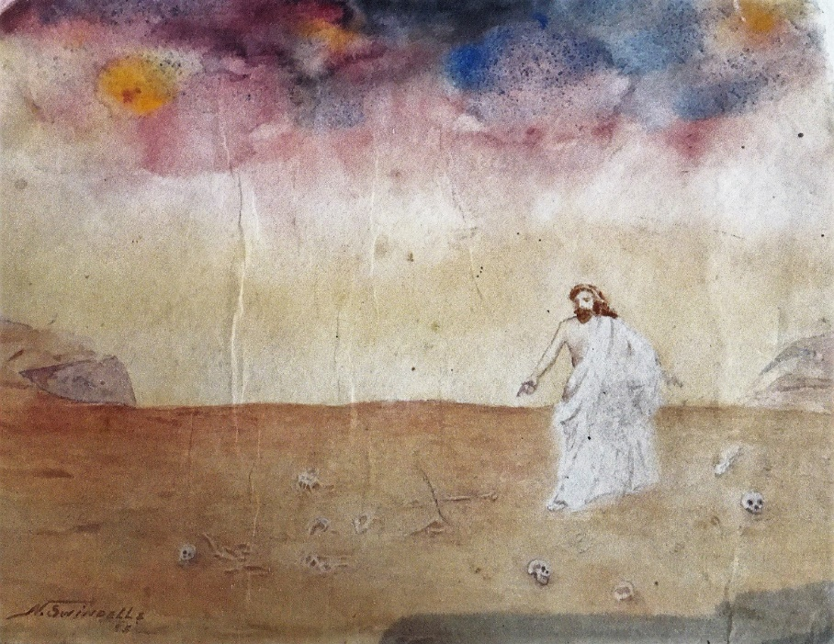  
**REFLECTION**

I wish to share with you a reflection from Richard Swanson’s reflection on this Sunday’s reading from John 11. In a time of separation, his reminder is timely.

*It is odd how different things leap out of a scene in different times. I had sort of imagined that exploring this scene this year would leave me thinking about the healing, or the messiah whose being is life out of death. I didn't know where it might go from there, but that's where I thought it might start.*

*Shows how much I know.*

*I read the scene, and all I see right now is the distance between Jesus and the friends who have called to him for help. I certainly see the offense of his choice to delay, just as I saw it three years ago in my Provocation, but this year I see the distance. We human beings are local beings: we are here, or we are there, and the distance between here and there is real.*

*My sense of the harsh reality of distance was sharpened this week when I read a piece written by a remarkable woman, Lori Byers Walsh, the host of a radio show on South Dakota Public Radio. Her show is called "In The Moment," and it is the show on which Murray Haar and I were interviewed the other week for a project called "The Future of Faith." You can find the link to this show in my Provocation:*[*https://provokingthegospel.wordpress.com/2020/03/05/a-provocation-the-future-of-faith-south-dakota-public-broadcasting-march-2020/*](https://public-api.wordpress.com/bar/?stat=groovemails-events&bin=wpcom_email_click&redirect_to=https%3A%2F%2Fprovokingthegospel.wordpress.com%2F2020%2F03%2F05%2Fa-provocation-the-future-of-faith-south-dakota-public-broadcasting-march-2020%2F&sr=1&signature=b779b06e8da26ff3e16b06a0f32a4e0e&user=48550740&_e=&_z=z)

*Walsh is deeply bright, incisive, kind, perceptive. She can also write beautifully, honestly, and well. This past week she wrote a piece about her daughter who goes to school in New York City, a piece about the reality of the distance between here and there. Read it. Really. Read it. You will hear the voice of a mother, a realist, a human being who can only be here, even when everything in her needs to be somewhere else.*[*https://www.sdpb.org/blogs/margins/from-a-distance-loving-someone-when-you-cant-be-together/?fbclid=IwAR0ZjelwZXVgbgr26hecE5QY4FMHWwwXF8YJfZBJTxREM9JrrApP8iPHGxw*](https://www.sdpb.org/blogs/margins/from-a-distance-loving-someone-when-you-cant-be-together/?fbclid=IwAR0ZjelwZXVgbgr26hecE5QY4FMHWwwXF8YJfZBJTxREM9JrrApP8iPHGxw)

*I hear pastors asking what it means that they have people in the hospital, people they cannot visit because of necessary limitations on visitors. I hear pastors asking how we can celebrate the Lord's Supper, how we can say "This is my body" as the Body of Christ, when we cannot do it as a gathered group. Yes, some of that discussion started with some fairly magical thinking: some were sure that we could gather together despite what the CDC advised around a common cup because we would be protected since we were the Body of Christ. That sort of thinking burned off fairly quickly. I'm not a fan of magical thinking, whether from pastors or presidents. Most of what I have read about being and sharing the Body of Christ in these strange times is pained and plaintive. We are connected and we are separated, and pastors feel both truths at once.*

***So do mothers. So do health care workers, quarantined from their families.***

*So maybe the bite of this scene comes in the metaphor of the Body of Christ. We of course ARE the Body of Christ, and we will share it (somehow) as we worship together separately (somehow). But just as I get nervous when a student tells me she wants to BE a professor, or to BE a pastor, or to BE a physician, so also I get nervous this week when the discussion is about BEING the Body of Christ.*

***I don't think it's about BEING anymore.***

*Maybe the question behind what I have been reading this week is about how, in these very strange and dangerous times, we can DO the Body of Christ. A messiah is not a static religious figure, some sort of spiritual picture of perfection. A messiah turns the world right-side-up. In this scene in John's story, turning the world right-side-up is a matter of raising Lazarus to life. This is not a circus trick, it is a down payment on the largest promises of God: death and separation do not have the last word. Justice is possible, and life can rise even when haunted by death.*

***As magical thinking, such talk annoys me.****But listen to how Walsh finishes her article:*

*Jane was alone for all of this, and she was never alone, in that way all of us are alone, and in that way none of us are ever alone, even during our darkest nights.*

*That thing you are afraid of? It might happen. Or it might not. Systems might fail, in spite of our best efforts. But, trust me on this one, you will find a way to be with the ones you love, even when you aren’t physically together, even if you have no idea what’s happening. Doctors and nurses and first-responders will find ways to save lives, even when they can’t save others. We will find a way to endure.*

*We are all on our own journeys of courage and humility now. In solitude. And in solidarity.*

***This is the Body of Christ, given for us all.***

You can access his material and reflections at <https://provokingthegospel.wordpress.com/author/richardwswanson/>.

**PRAYER FOR OTHERS** Rev. Linda Young

Loving God, Creator of the Universe and all that there is,

We bow before you with humility acknowledging that know not what is before us. We pray for those who have been affected by this virus that has come upon us. We pray for comfort and peace in our spirits, in this uncertain time.

Lord, may they know your presence through these challenging times…

We pray for those caring for the sick, the elderly and the children, for doctors and nurses, for healthcare providers and emergency services.

Lord, may we all know your presence through these challenging times…

We pray for all those working in the essential services, in the supermarkets and petrol stations, the post offices and the pharmacies. We pray that their spirits may be encouraged and that they may be kept safe.

Lord, may we all know your presence through these challenging times…

We pray for all those working from home, looking after their families, finding productive things to do to; keep spirits up. We pray for those who are home alone and struggling at this time. May we all during these times of unexpected isolation be moved to reflect on the important things of life; to cherish what they have and to find You in all things.

Lord, may we all know your presence through these challenging times…

Now, a moment of silence to pray specifically for those in need at this time…

In the name of the God of Creation, and his Son Jesus we pray. Amen

**PAUSE TO REMEMBER AND GIVE THANKS:** *Pause; have a bite to eat; thank God for the stories of scripture and God’s presence in your life story. Have a sip of your drink; remember Jesus’ gift of himself for us all; thank God for the transformation he brings in Jesus.*

**PRAYERS OF THANKSGIVING:** *(~ written by Eliza Buchakjian-Tweedy, Pastor at First Church Congregational, Rochester, NH.  She blogs at*[*http://sermonizing.wordpress.com/*](http://sermonizing.wordpress.com/)*)*

Source of life, and breath, and being,

breathe into the dry dust of our existence.

Nourished in body by food and drink,

may we strive for the nourishment of all bodies:

may we work to end hunger in this creation that provides amply for all.

Nourished in spirit by the Body which is within our own,

may we strive for the incorporation of all:

may we work to break the barriers that keep us from you.

In the love that sustains us, and the Spirit that energises us,

may we give all thanks and praise to you, God of all.  Amen.

**COMMISSION AND BLESSING**

We who are physically scattered but united in Christ,

follow Jesus on the way to the cross;

to receive that new life he offers to all who believe.

May the breath of God give you life  
May the compassion of Jesus Christ shape your life  
May the power of the Holy Spirit stimulate your life.

Go in peace to love and serve the Lord.